6.3 Use Jasmine to Test an Angular Application

This section will guide you to:

* Install ng node module to run an Angular App
* Configure Jasmine unit test cases

This guide has two subsections, namely:

6.3.1 Initializing Node JS ng module to create a demo project

6.3.2 Configuring Jasmine unit test cases

**Step 6.3.1:** Initializing Node JS ng module to create a demo project

* Connect to the virtual machine using root user and use the command given below to install ng command line.

*npm install ng -g*

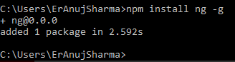

* Create new angular testing project using the command as ng new angular-unit-test.

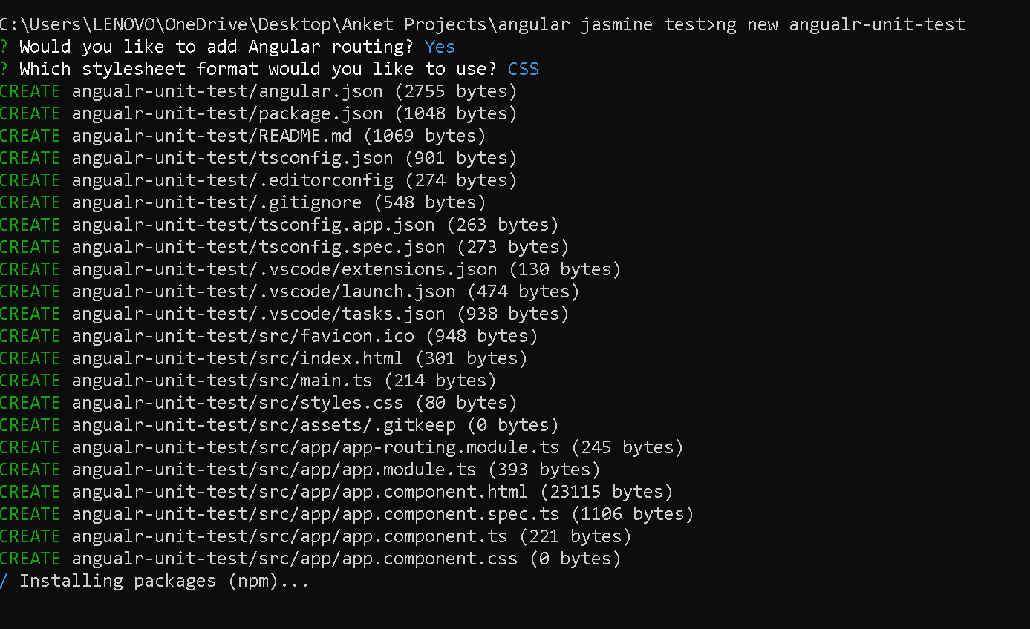

By default angular provide unit testing configuration as well as it provided sample unit test file for the component with name as app.component.spec.ts file

File present inside a src 🡪 app🡪app.component.spect.ts file

import { TestBed } from '@angular/core/testing';

import { RouterTestingModule } from '@angular/router/testing';

import { AppComponent } from './app.component';

describe('AppComponent', () *=>* {

  beforeEach(async () *=>* {

    await TestBed.configureTestingModule({

      imports: [

        RouterTestingModule

      ],

      declarations: [

        AppComponent

      ],

    }).compileComponents();

  });

  it('should create the app', () *=>* {

*const* fixture = TestBed.createComponent(AppComponent);

*const* app = fixture.componentInstance;

    expect(app).toBeTruthy();

  });

  it(`should have as title 'angualr-unit-test'`, () *=>* {

*const* fixture = TestBed.createComponent(AppComponent);

*const* app = fixture.componentInstance;

    expect(app.title).toEqual('angualr-unit-test');

  });

  it('should render title', () *=>* {

*const* fixture = TestBed.createComponent(AppComponent);

    fixture.detectChanges();

*const* compiled = fixture.nativeElement as HTMLElement;

    expect(compiled.querySelector('.content span')?.textContent).toContain('angualr-unit-test app is running!');

  });

});

Angular internally provide configuration for unit testing develop Jasmine testing framework and Karma as test runner to display the output on browser.

To run test case we have to run the command as

**ng test**

output on terminal

